Testing Steps for Dev Environment
- Material Quantity
- Pricing
Here you can estimate price require as per your requirement(Price for the entire process)
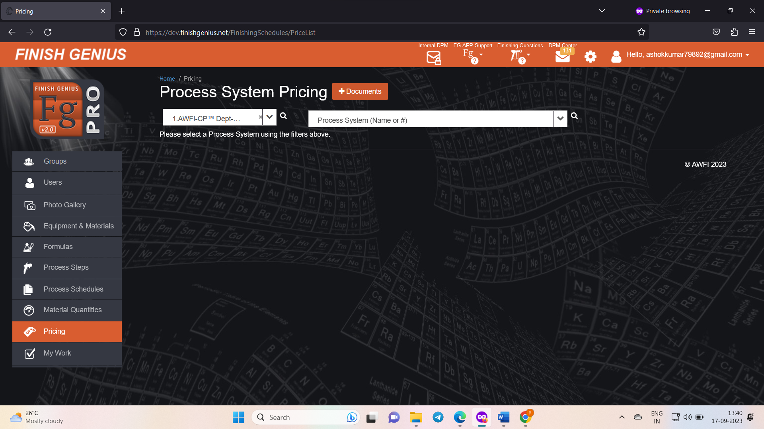

Step-1 Select the group and process
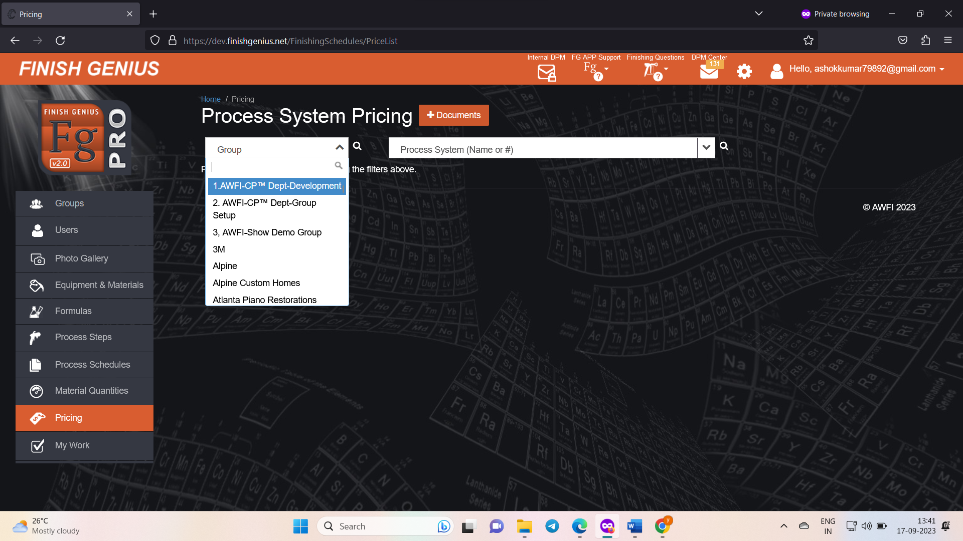
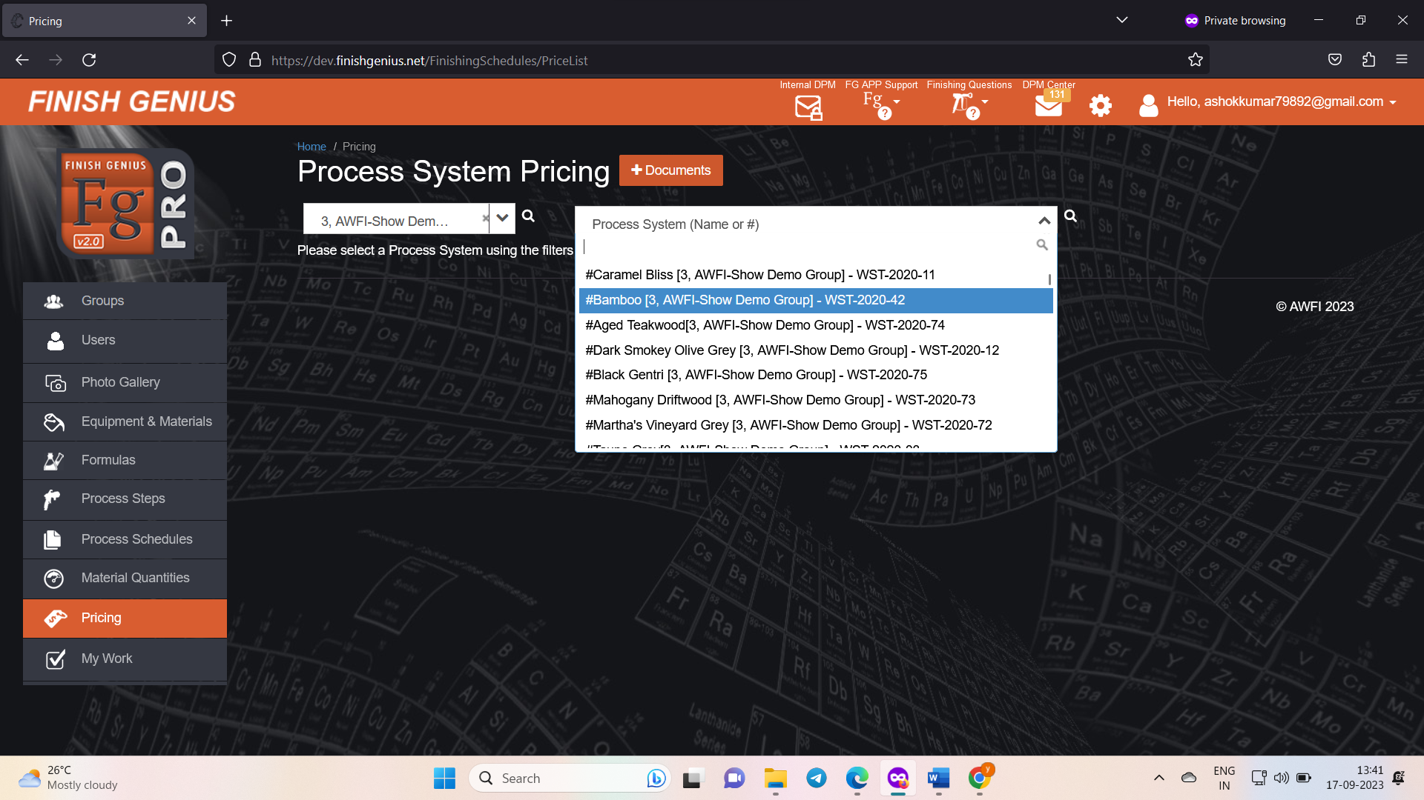
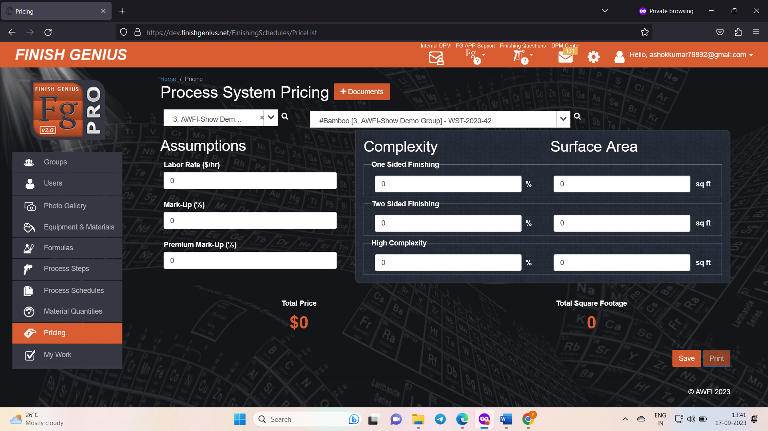

Step-2: Enter the details as per your requirement and you will get price
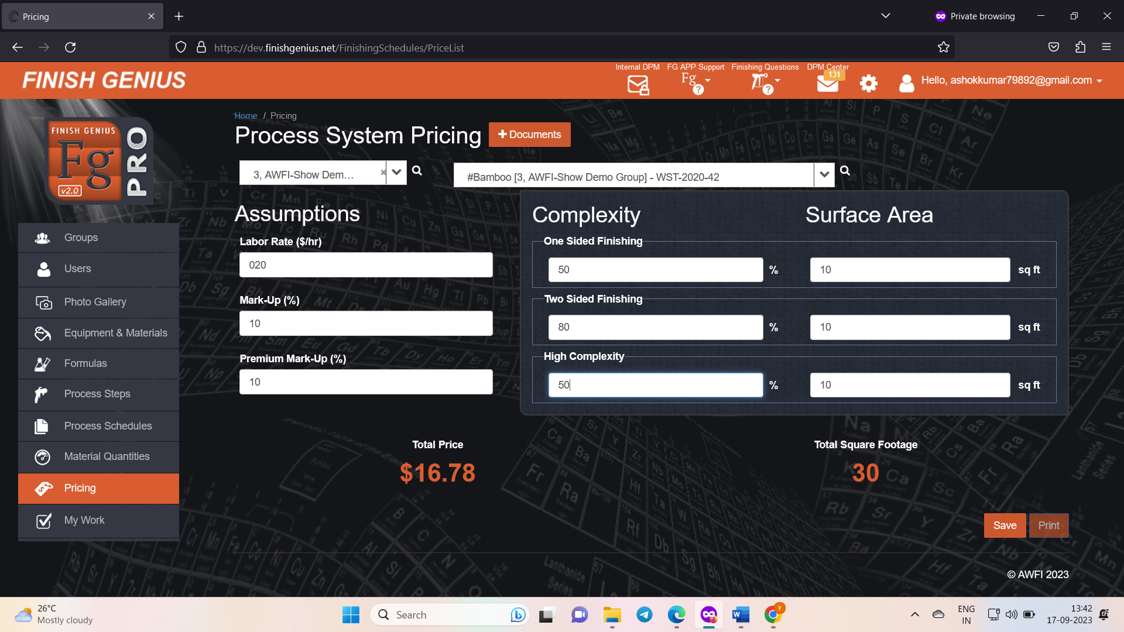

Conclusion
- Pricing Feature is working properly

